DAD 220 Module Five Major Activity Template

Overview

Review the scenario for this activity in the guidelines and rubric. Then complete the steps below as you work through the directions for this activity. Replace the bracketed text with your screenshots and responses to the prompts. Size each screenshot and its explanation to fit approximately one-quarter of the page with the description written below the screenshot. Review the Template Screenshot Example linked in the guidelines and rubric for this assignment to see an example of how screenshots for your assignment should look.

Create a Database

- Write SQL commands that capture specific, usable data that can be used in your analysis.

- Analyze the results of queries to identify specific information that can be presented in your summary.
  - Sales by region:
    - Analyze sales data by state to determine where the company has the largest customer base.

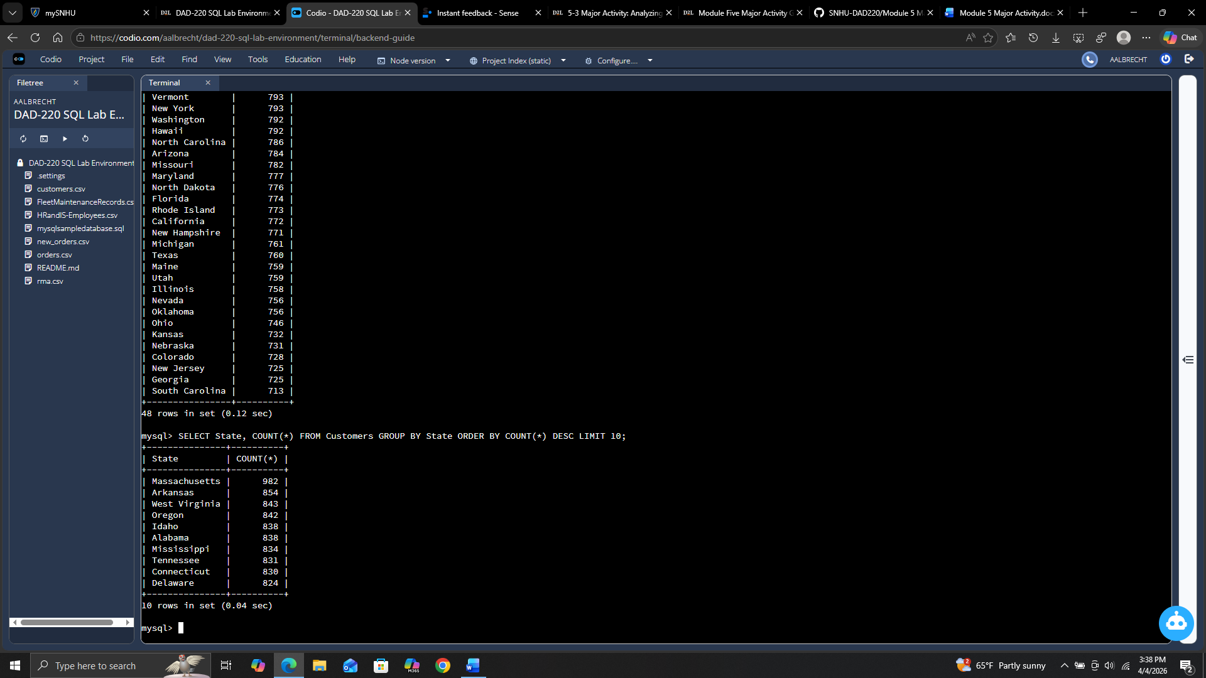

The largest customer base is in Massachusetts with 982 customers followed by Arkansas with 854 and West Virginia with 843.

    - Analyze the data to determine the top three products sold in the United States.

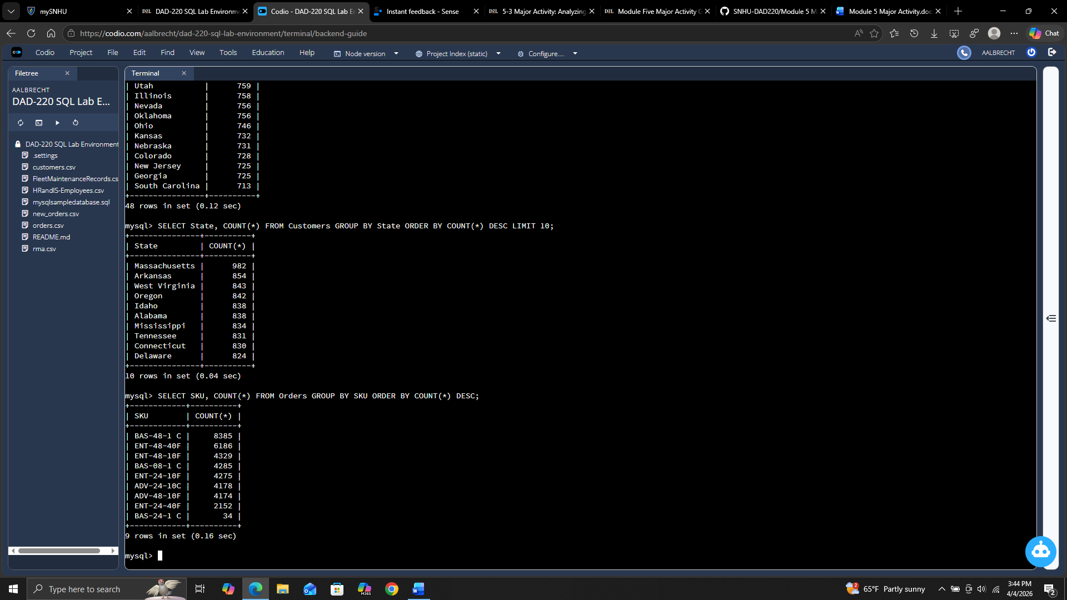

The top 3 products sold are BAS-48-1 C at number 1, ENT-48-40F at number 2, and ENT-48-10F at number 3.
    - Analyze the data to determine the top three products sold in the southeastern region of the United States.
- Southeastern states to include in your analysis: Virginia, North Carolina, South Carolina, and Georgia

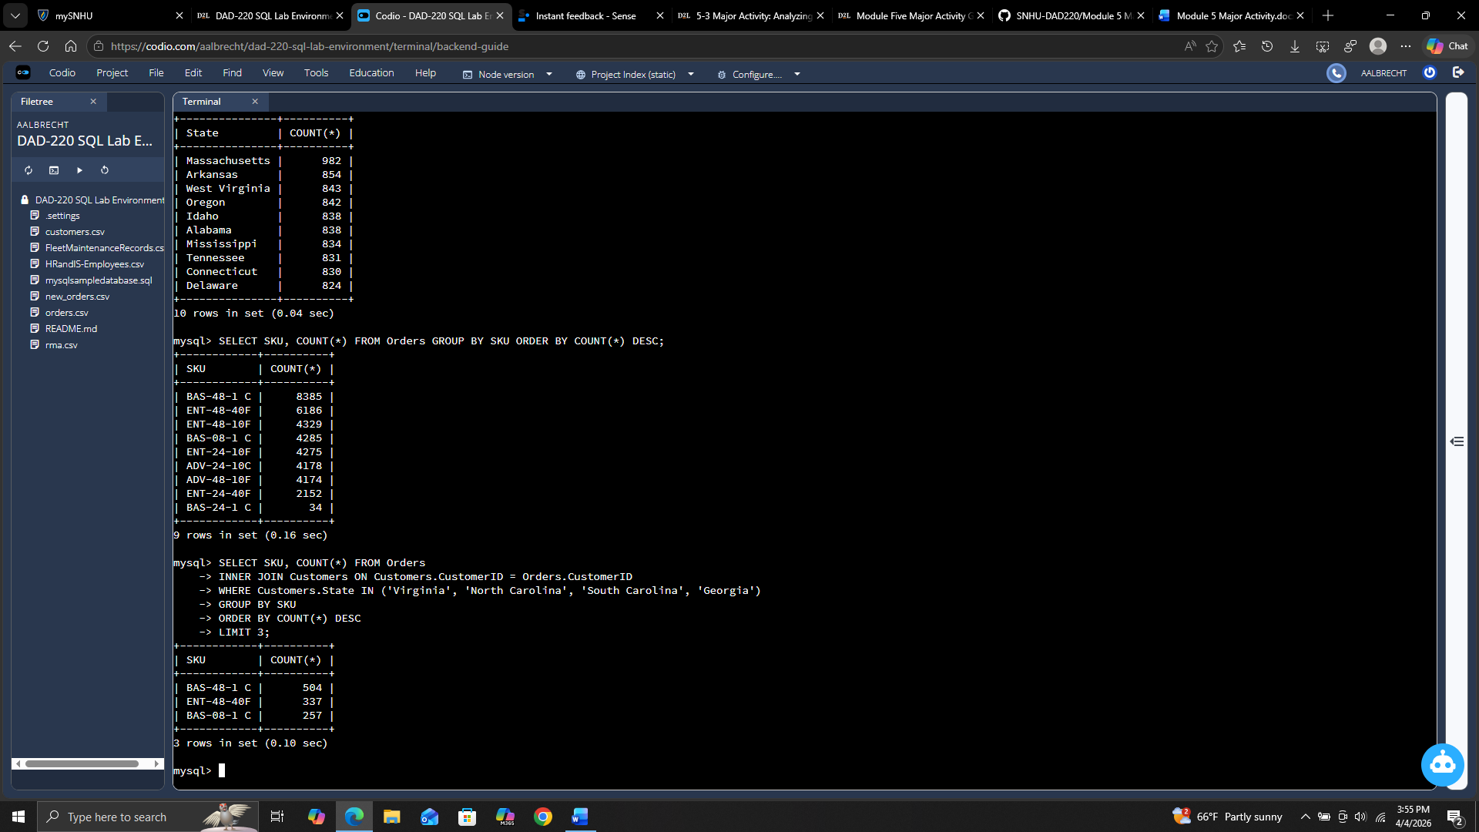

The top 3 products in the southeastern US are BAS-48-1 C as number 1, ENT-48-40F as number 2, and BAS-08-1 C as number 3.

  - Returns by region:
    - Analyze the data to determine the top three products returned in the United States.

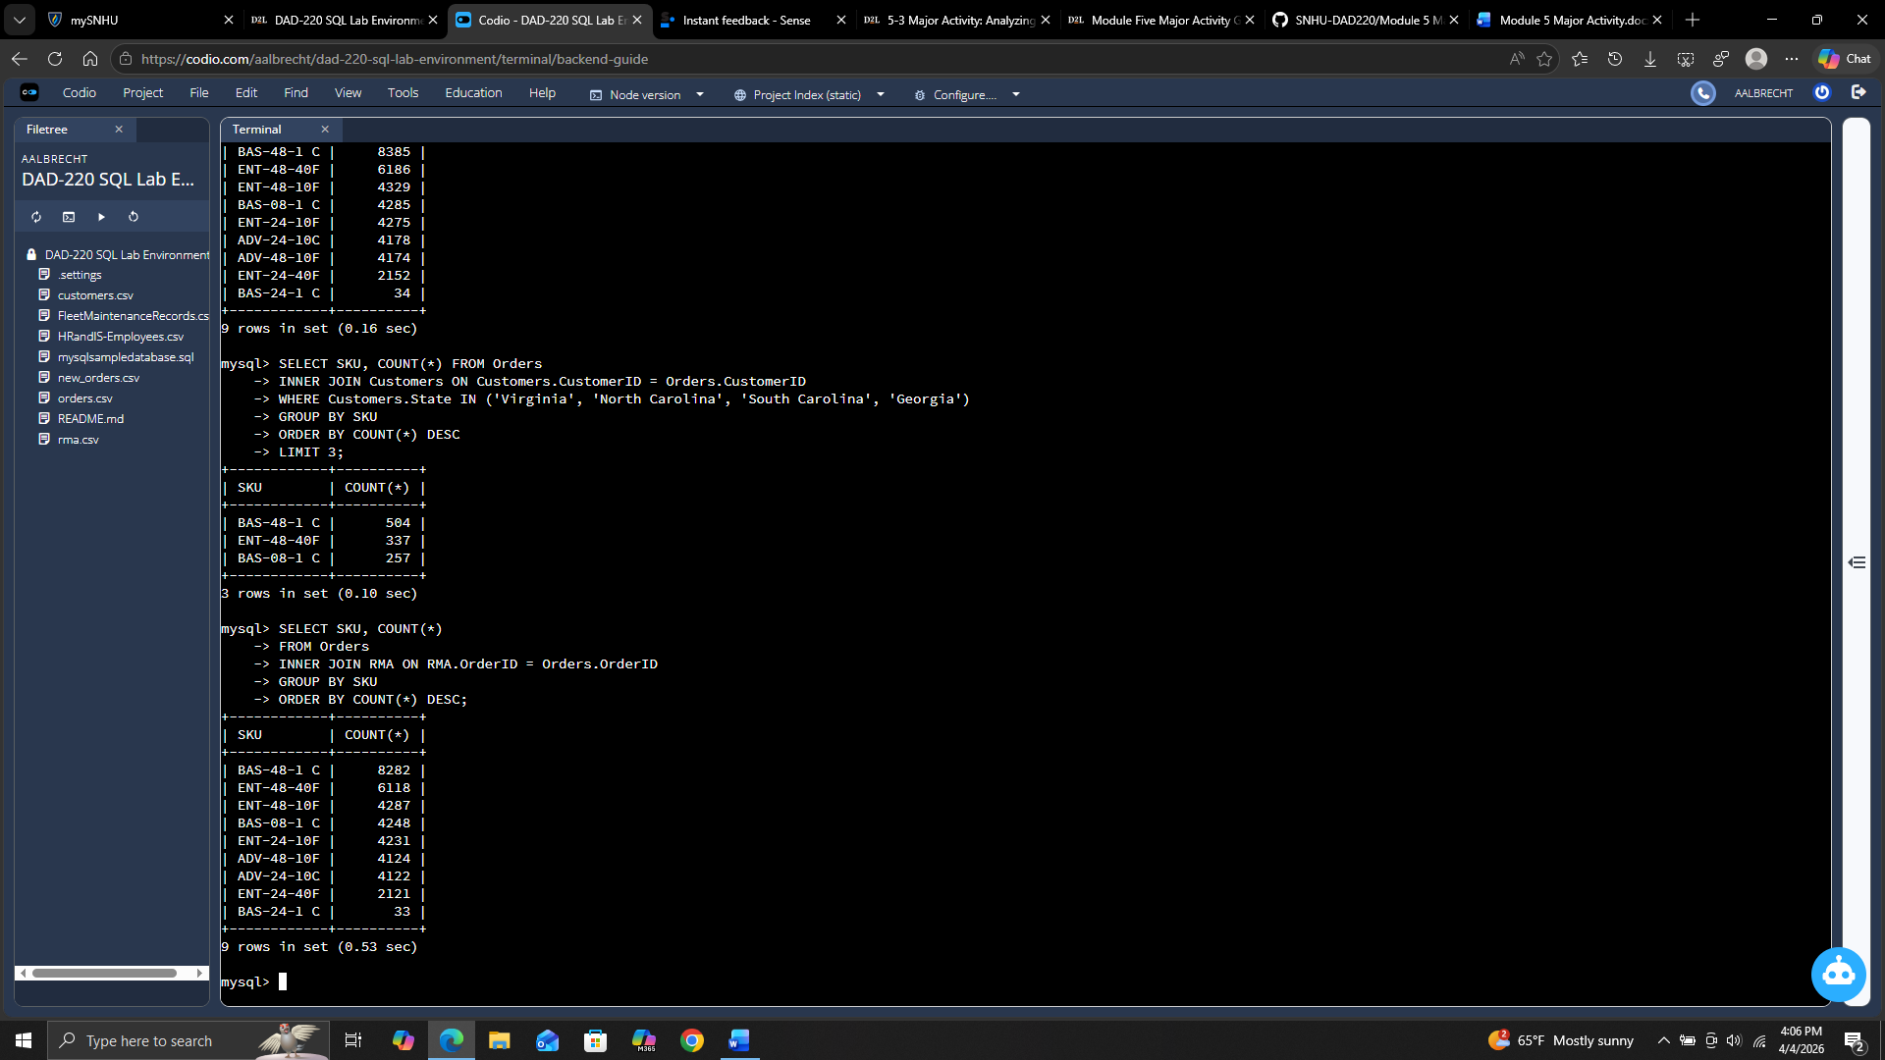
The top 3 returned products were BAS-48-1 C as number 1, ENT-48-40F as number 2, and ENT-48-10F as number 3.

    - Analyze the data to determine the top three products returned in the northwestern region of the United States.
- Northwestern states to include in your analysis: Washington, Oregon, Idaho, and Montana

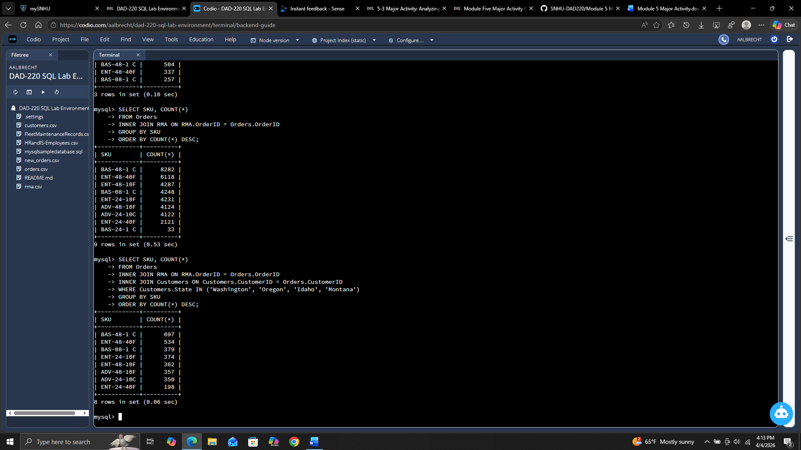

The top 3 products in the northwestern US are BAS-48-1 C as number 1, ENT-48-40F as number 2, and BAS-08-1 C as number 3.

- Write a report to the Quantigration product manager that explains your findings in a way nontechnical stakeholders can understand and use.
  - Provide an effective summary of your findings from the analysis of the sales and returns data you captured. Write at least one paragraph for each of your responses to the prompts below.

    - Sales data by region: Provide a well-written summary of findings from your analysis in Step Two, Part A.

The highest customer base is located in Massachusetts. The top 3 products that were sold are BAS-48-1 C, ENT-48-40F, and BAS-08-1 C. The top product sold almost double the amount of the 3rd top product. The 2nd top product sold about 50 percent more than the 3rd top product. Those top 2 products are clearly outselling everything else. I would recommend using this information to figure out why they sell so much more and see if that is something that can be applied to the other products.

    - Returns data by region: Provide a well-written summary of findings from your analysis in Step Two, Part B.

The returns of these products are alarming. Even with different regions, 2 of the top 3 products are returned. BAS-48-1 C and ENT-48-40F are the 2 previously mentioned. They have almost as high a return rate as the purchase rate. I recommend researching into why these products seem to be so popular but yet almost no one keeps the purchase.

